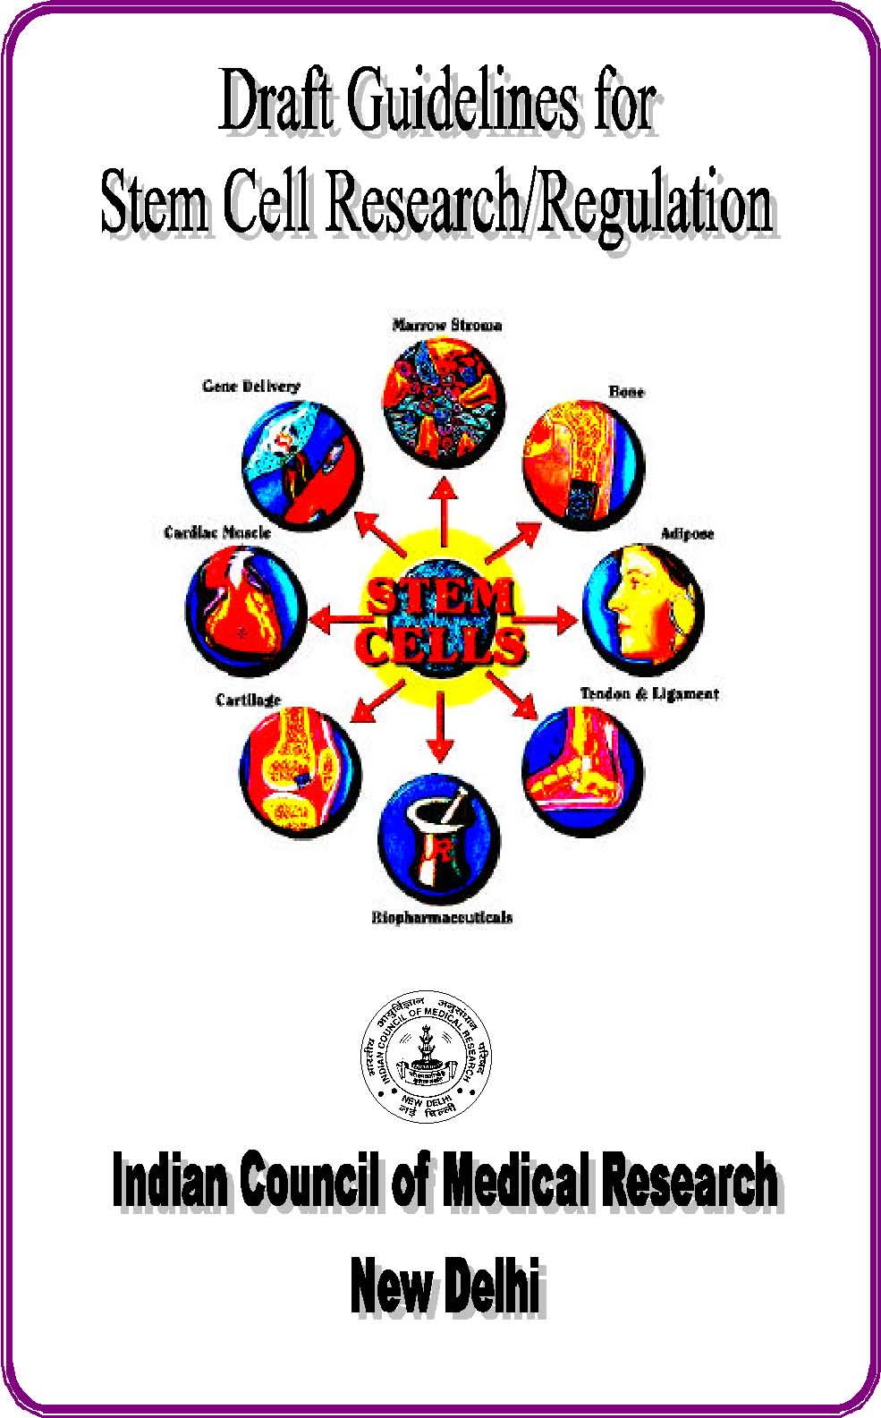

INDIAN COUNCIL OF MEDICAL RESEARCH
Guidelines for Stem Cell Research/Regulation in India Introduction
he profound characteristic of a stem cell is its capacity for extensive self-renewal and retention of multilineage differentiation potential. Recent research suggests that human stem cells can give rise to many different types of cells, such as muscle cells, nerve cells, heart cells, haematopoietic cells etc, giving the hope for major advances in health care. The era of clinical marrow, tissue and organ transplantation is poised for breakthrough with the possibility of stem cell transplantation and therapy. Realising the potentials of this new technology in modern therapeutics and biomedical research it is strongly recommended that Stem cell research and its clinical applications should be promoted in the country. However, it is desirable that all new technologies and techniques should be thoroughly examined before approving of any such research. application. There is a need to have a regulatory body (an Apex body).
Sources of stem cells are as follows:
i) Adult stem cell : Derived from peripheral blood, tissue or bone marrow
ii) Cord Blood Cell : Derived from placenta
iii) Embryonal stem cells: Derived either from blastocysts or foetal tissues
I. Adult stem cells : Adult bone marrow cells have been used for more than a decade. Stem cells in adult tissue are often multipotent and can produce many, but not all cell types. These cells can be multiplied but do not have an unlimited capacity for renewal like the embryonic stem cells. Research is ongoing to determine whether these cells can also be made to differentiate into other tissues.
II. Cord Blood cells : Stem cells are also obtained from aborted fetal tissue and umbilical cord blood and have shown to be successful in reconstitution of bone marrow in children in many diseased conditions. These stem cells and those from the adults are multipotent in nature.
They can be multiplied and maintained in culture but do not have unlimited capacity for renewal like the embryonic stem cells. Research is ongoing to determine whether these cells can also be made to differentiate into other tissues. Use of fetal stem cells will reduce the amount of foetal tissue used for various therapies. Since Medical Termination of Pregnancy is permitted in this country under the MTP Act of 1971 fetal tissue will be freely available from the MTP clinics and hospitals. TERMINATION OF PREGNANCY FOR OBTAINING FOETUS FOR STEM CELLS, research or for transplantation will not be permitted.
III. Embryonal Stem cells : These are pluripotent and have the capacity to develop into any cell of the body. These are obtained from the very early stages of the embryonic development probably upto 2-4 cell stage in humans i.e. within 5-7 days of conception. Scientists believe that these cells can be directed in the laboratory to differentiate into any cell or tissue to treat many diseases affecting various tissues and organs for example : Parkinson’s disease, Alzeimer’s disease, leukaemias, multiple sclerosis, spinal cord injuries, burns, cancer etc to name a few. Further it is expected to provide unlimited supply of tissues and organs for transplantation which are in grave short supply. Research on stem cells also promises to improve our understanding of the complexities of human development differentiation and the disease processes. But before this step is reached a lot of basic research is required
The main source of embryonic stem cells will be from the ART/IVF clinics dealing with Infertility treatment where SPARE OR SUPERNUMERARY embryos will be available for these purposes. However no embryo can be CREATED for the sole purpose of obtaining stem cells.
National Apex Committee (NAC) for cell based research & therapy
ICMR should be the Regulatory Authority in the area of Biologicals. A National Apex Committee for mammalian cell based Research & Therapy should be set up which should be vested with regulatory powers.
A speaking order is to be issued by Ministry of Health & Family Welfare that all proposals invo lving stem cells of any source should be cleared by this National Apex Committee. All centres should be registered with this committee.
Scope :
The Committee will have the responsibility to examine the scientific, technical, ethical, legal and social issues in the area of cell based research and therapy.
Scientific/Technical Issues :
All proposals either from public or private sector for research or therapy should be placed before this Committee for clearance after recommendation through appropriate scientific peer review mechanism. (Only those proposals for research or therapy either from public or private sector recommended by appropriate scientific peer review committee should be placed before this Committee for consideration). These proposals should also be cleared by the Institutional Ethics Committee before submitting to Apex Committee.
Research on stem cells includes both basic and applied aspects. Currently this technology has potential for therapy through regeneration of tissues or implantation of cell and tissues in Nervous system diseases e.g. Parkinson’s disease, Alzheimer’s, Multiple sclerosis, spinal cord etc., Cardiac infarction, Bone and Cartilage diseases, Cancer and immune diseases, Diabetes etc. and burns.
Ethical, legal and social issues :
Institutional Ethics Committee should keep in view the ethical, legal and social issues and should adhere to the “Ethical guidelines for Biomedical Research on Human Subjects” issued by the ICMR in October, 2000 while reviewing the proposals.
Membership of the Committees :
- Chairman
- Deputy Chairman
- Member Secretary
- Membership :

a) Nominees
i) DBT
ii) DST
iii) CSIR
iv) ICMR
v) DCGI
vi) DAE
b) Biomedical experts : Experts can be co-opted for specific projects. i) Pharmacologist – clinical ii) Cell Biologist iii) Clinician iv) Haematology/Genetics v) Developmental biologist C) Others i) Legal expert ii) Social scientist iii) Women’s representative
Committee meetings :
Quarterly, but can be more frequent, if necessary.
Processing fees :
This will be levied for proposals on therapeutic trials with NBEs (New Biological Entities).
Guidelines :
I Adult Stem Cells
Use of adult stem cells does not pose major ethical problems at present, as these are easy to obtain. All centres doing stem cell transplantation should register with this Committee. Bone marrow, peripheral blood, skin, limbal cells are some of the tissues in use.
-Proper informed consent procedures are to be followed as given in the ICMR ethical guidelines.
-Storage and preservation Standard Operating Procedures (SOPs) should be followed.
-In vivo studies : Experimental work on stimulation of adult stem cells also has tremendous future. Approval from NAC must be sought for carrying out these experiments, clinical or therapeutic trials.
II Cord Blood Stem Cells
For using umbilical cord blood from a live foetus or a neonate it must be ensured that no harm should occur to the foetus or the neonate. Since the exact timing of the clamping of the umbilical cord has a significant impact on the neonate and early clamping may cause an abrupt surge in arterial pressure resulting in cerebral intraventricular haemorrhage, particularly in premature neonates, normal clamping protocol will be followed when collecting foetal blood for transplantation. There is a risk that the neonate donor may need his or her own cord blood later in life. If the blood has been used for another, he or she might be left without much needed blood. Parents will be informed of the risks of donation and a written consent will be obtained from them on behalf of the foetus.
Cord blood stem cells is generally used for haemopoietic stem cell transplantation. For any other form of therapy detailed protocol has to be submitted for approval.
III Fetal stem cells/tissue :
These can be processed from spontaneously aborted foetus or from fetuses obtained from MTP clinics. Guides for foetal tissue transplantation as specified in ICMR guidelines should be followed. DNA fingerprinting of the cell line should be preserved and it is advised to keep it in cell repository. Generally EG cells will be permitted only for experimental purposes at present. Any therapeutic transplantation will not be permitted at present and this possibility will be examined at an appropriate time later.
IV Embryonic stem cells (ES Cells)
Embryo should not be generated for the sole purpose of obtaining stem cells. Only surplus or spare or supernumery embryos can be used with the permission of the couple from registered ART clinics. Cell lines generated should be registered. At present only research programme relating to in vitro induction of differentiation into various cell lines will be cleared by the Committee (NAC) on case to case basis. Any therapeutic trial will be examined in detail. Reproductive cloning will not be permitted on ethical grounds. At present human cloning is not permitted for the purpose of creating a new individual. However, in special situations where cloning is for therapeutic purposes with regard to cells, tissues or organs, the Committee will examine them on a case to case basis.
Monitoring Mechanism
A central monitoring committee – a sub-committee of the Apex Committee – should be constituted to make site visits as and when required.
Annual report should be submitted in appropriate format for further continuation of the project by 10th month of commencement of the project decision and review should be communicated in 4-6 weeks.
Any violation of guidelines would be strictly dealt with.
Commercialisation and Patent issues
Established stem cell lines can have considerable commercial value as wide ranging potential benefits for large number of patients is possible. Patent issues need wider discussion and public debates should be held on who should be the beneficiary and what type of patents can be taken.
Regulation of stem cell lines
All cell lines should be registered with this committee. All proposals for therapeutic trial should be cleared by this committee before submitting to DCGI.
International collaboration
National guidelines of respective countries should be followed. Collaboration will be permitted only after the joint proposal with appropriate MOU is approved by the Health Ministry’s Screening Committee following clearance by the Apex Committee. No export of cell lines per se will be permitted.
Generation of ES cells from non-human sources
ES cells for experimental purposes can also be obtained from sources such as rodents, primates, domestic animals, farm animals etc. Research in these areas should be encouraged.
Check list to be submitted to the National Apex Committee for any proposal :
- Title of the proposal
- Institution concerned
- Investigators’ name with brief biodata and relevant publications
- Source of funding
- An assurance signed by the responsible institutional head that the pluripotent stem cells were derived from human embryo in accordance with the guidelines.?
- Informed consent document duly signed by appropriate individuals.
- Brief summary of the proposed work.
- IRB/IEC clearance
- Certificate that no undue inducements/incentive is provided for donation of embryo.
- Separate consent forms for infertility treatment and donation of embryos to be taken.
- Certificate that only spare embryos are being used.

Private sector involved in such research should also come under the purview of this committee and it should comply with these safeguards and standards and submit all proposals for clearance.

Expert Group Members
- Dr. P.N. Tandon, New Delhi Chairman
- Dr. S.S. Agarwal, ACTREC, Mumbai
- Dr. N.K. Mehra, AIIMS, New Delhi
- Dr. Dipika Mohanty, IIH, Mumbai
- Dr. Y.N. Rao, DGHS, New Delhi
- Sh. Ashwini Kumar, DCGI, New Delhi
- Dr. Narayan Swamy, Dy. DCGI, New Delhi
- Dr. Hari Gopal, DST, New Delhi
- Dr. T.S. Rao, DBT, New Delhi
- Dr. Alka Sharma, DBT, New Delhi
- Dr. C.M. Habibullah, DCMC & Allied Hospitals, Hyderabad
- Dr. U.V. Wagh, NCCS, Pune
- Dr. Vinod Raina, AIIMS, New Delhi
- Dr. Vineeta Salvi, KEM, Mumbai
- Dr. Satish Kumar, CCMB, Hyderabad
- Dr. G.R. Chandak, CCMB, Hyderabad
- Dr. Ambika Nanu, AIIMS, New Delhi
- Dr. S.G.A. Rao, Reliance, Mumbai

Drafting Committee
- Dr. A.N. Bhisey, CRI, Mumbai Chairman
- Dr. U.V. Wagh, NCCS, Pune
- Dr. D. Mohanty, IIH, Mumbai
- Dr. P.B. Seshagiri, IISc, Bangalore
- Dr. M.G. Deo, Moving Academy, Pune
- Dr. V. Salvi, KEM, Mumbai
- Dr. S.S. Agarwal, ACTREC, Mumbai
- Dr. K. Ghosh, IIH, Mumbai
- Dr. V. Muthuswamy, ICMR, New Delhi Member Secretary

������

